Objective:

The aim of this assignment is to build a Bayes Classifier using a Gaussian Mixture Model (GMM), where the parameters (mean, covariance matrix, and mixing coefficients) are initialized using the K-means clustering algorithm. The classifier will be trained on image datasets and used to classify test images into distinct categories.

1. Introduction:

Dataset 2(b): Real-world Data
This includes:
- 3-Class Scene images dataset: This dataset includes Training & Testing Dataset, In each this dataset, it has three classes namely botanical_garden, bus_interior and elevator_shaft, each of this class having 50 samples.so in total 150 samples are there in Training dataset and 150 samples are there in Testing Dataset.
- Where each image or samples from each class of training dataset is divided into patches and then extract the feature from these patches of an image. there are two different ways of representation for this process of feature extraction as given below:
    - 24-dimensional colour histogram vectors:
- Consider 32 x 32 non overlapping patches on every image (from training and test sets). For example, if the image size is 256 x 256, there will be 32 numbers of 32 x 32 non overlapping patches.
- Extract 8-bin colour histogram from every colour channel (R, G and B) from a patch. It results in 3, 8-dimensional feature vectors. Concatenate them to form a 24-dimensional feature vector.
- Similarly extract 24-dimensional feature vectors from every patch.
- Stack the 24-dimensional feature vectors corresponding to every patch in an image and save them as a file in the corresponding class folder.
- Thus, an image is represented as set (collection) of 24-dimensional colour histogram vectors representation
- Repeat the above steps to all the images in training and test sets of all the classes.
32-dimensional Bag of Visual Words (BoVW) feature vectors:

- Colour Histogram computed as follows from a colour channel: Note that colour histogram is computed at every patch.
- When the given image is read, it will be read as a 3-dimensional matrix of pixel values. Each patch of an image is also a 3-dimensional matrix of pixel values. Each dimension is corresponding to a colour channel. The pixel values in each colour channel are in the range 0 to 255.
- For a colour channel:
- Divide this range into 8 equal bins.
- Count the number of pixels falling into each bin. This results in a vector of 8 values.
- This is the 8-dimensional colour histogram (from a colour channel) feature vector.
- Normalise this vector by dividing it by the number of pixels in that patch.
- Do the same for other colour channels. Concatenate those three 8-dimensional colour histogram vectors to form a 24-dimensional vector.

2. Implementation:

1.K-means Clustering Algorithm
The K-means clustering algorithm follows these steps:

a. Cluster Assignment (Similarity Calculation)
- The cluster assignment step is based on the Euclidean distance between each data point $x_{n}$ and the current centroid $μ_{k}$ of the $k$-th cluster. The distance is computed as:
$$\text{distance}\left(x_{n},μ_{k}\right)=∥x_{n}-μ_{k}∥^{2}={\left(x_{n}-μ_{k}\right)}^{T}\left(x_{n}-μ_{k}\right)$$
- Where:
  - $x_{n}$ is the $n$-th data point.
  - $μ_{k}$ is the centroid of the $k$-th cluster.
- Each data point is assigned to the cluster with the minimum distance.

b. Updating Centroids
- After assigning each data point to a cluster, the new centroid $μ_{k}$ for the $k$-th cluster is updated as the mean of all points assigned to that cluster:
μk=1Nkxn∈Ck​xn
- Where:
  - $N_{k}$ is the number of points assigned to the $k$-th cluster.
  - $C_{k}$ is the set of all points assigned to the $k$-th cluster.
$c.$ Covariance Matrix Update
The covariance matrix $Σ_{k}$ for each cluster is calculated as:
Σk=1Nkxn∈Ck​xn-μkxn-μkT

d. Convergence Criterion
- The algorithm iterates between the cluster assignment and centroid update steps until the centroids no longer change significantly (i.e., the change in centroids is smaller than a threshold).
- Once the Clustering is done for each individual classes using K-Means Clustering Algorithm, now we Final Values of Parameters of each cluster for very class. Which will be further used as initialized value for building the Gaussian Mixer Model, then GMM algorithm runs on training dataset of each class. where they are represented as GMM for class 1 is θ1, for class 2 is θ2 and for class 3 is θ3.

2. GMM (Gaussian Mixture Model) - EM Algorithm
- The Expectation-Maximization (EM) algorithm is used to train the Gaussian Mixture Model (GMM), which involves the following steps:

a. Gaussian Probability Density Function (PDF)
- The formula used to compute the likelihood of a sample $x_{n}$ under a Gaussian distribution $N\left(x_{n}∣μ_{k},Σ_{k}\right)$ is given by:
$$p\left(x_{n}∣μ_{k},Σ_{k}\right)=\frac{1}{{\left(2π\right)}^{d/2}∣Σ_{k}∣^{1/2}}exp\left(-\frac{1}{2}{\left(x_{n}-μ_{k}\right)}^{T}Σ_{k}^{-1}\left(x_{n}-μ_{k}\right)\right)$$
- Where:
  - $d$ is the dimensionality of the data.
  - $x_{n}$ is the $n$-th data point.
  - $μ_{k}$ is the mean of the $k$-th Gaussian component.
  - $Σ_{k}$ is the covariance matrix of the $k$-th Gaussian component.
  - $∣Σ_{k}∣$ is the determinant of the covariance matrix.
  - $Σ_{k}^{-1}$ is the inverse of the covariance matrix.

b. Responsibilities (Expectation Step)
- The responsibility $γ_{nk}$ (probability that the $n$-th sample $x_{n}$ belongs to the $k$-th Gaussian component) is computed in the Expectation step (E-step) as:
$$γ_{nk}=\frac{π_{k} N\left(x_{n}∣μ_{k},Σ_{k}\right)}{\sum_{j=1}^{K}{π_{j}} N\left(x_{n}∣μ_{j},Σ_{j}\right)}$$
- Where:
  - $π_{k}$ is the mixing coefficient (weight) for the $k$-th Gaussian component.
  - $N\left(x_{n}∣μ_{k},Σ_{k}\right)$ is the Gaussian PDF as defined above.
  - The denominator is the sum of Gaussian PDFs over all $K$ components.

c. Updating Means (Maximization Step)
- The updated mean $μ_{k}$ for each Gaussian component is calculated using the responsibilities in the Maximization step (M-step):
$$μ_{k}=\frac{\sum_{n=1}^{N}{γ_{nk}}x_{n}}{\sum_{n=1}^{N}{γ_{nk}}}$$
- Where:
  - $γ_{nk}$ is the responsibility that sample $x_{n}$ belongs to the $k$-th Gaussian component.
  - $N$ is the total number of data points.

d. Updating Covariances (Maximization Step)
- The updated covariance matrix $Σ_{k}$ for each Gaussian component is:
$$Σ_{k}=\frac{\sum_{n=1}^{N}{γ_{nk}}\left(x_{n}-μ_{k}\right){\left(x_{n}-μ_{k}\right)}^{T}}{\sum_{n=1}^{N}{γ_{nk}}}$$
- Where:
  - $γ_{nk}$ is the responsibility of the $n$-th sample for the $k$-th Gaussian component.
  - $x_{n}-μ_{k}$ is the difference between the sample and the updated mean for the $k$-th component.

e. Updating Weights (Mixing Coefficients)
- The updated mixing coefficient (weight) $π_{k}$ for the $k$-th Gaussian component is:
$$π_{k}=\frac{1}{N}\sum_{n=1}^{N}{γ_{nk}}$$
- Where:
  - $N$ is the total number of data points.
  - $γ_{nk}$ is the responsibility of the $n$-th sample for the $k$-th Gaussian component.

f. Log-Likelihood Calculation
- The log-likelihood $L$ is computed at each iteration to track the convergence of the EM algorithm:
$$L=\sum_{n=1}^{N}{log}\left(\sum_{k=1}^{K}{π_{k}} N\left(x_{n}∣μ_{k},Σ_{k}\right)\right)$$
- Where:
  - $N$ is the number of data points.
  - $K$ is the number of Gaussian components.
Once the GMM is build for each of class, then we will compute the likelihood for new test sample feature vector x and the final label for new test sample is, which has maximum likelihood.
Class Label for x = argmax $p(\frac{x}{θi})$

3.Experimental Results: When Number of Component/Cluster is K=1

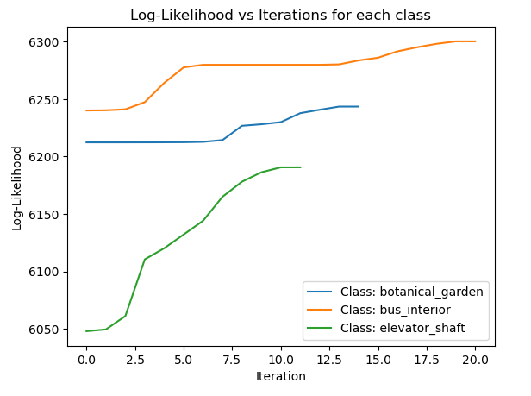
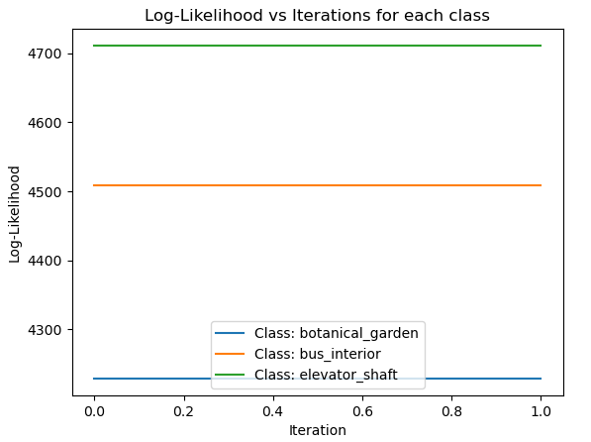
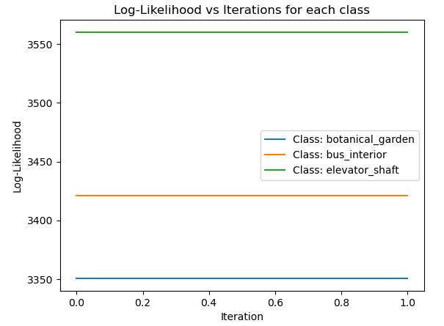
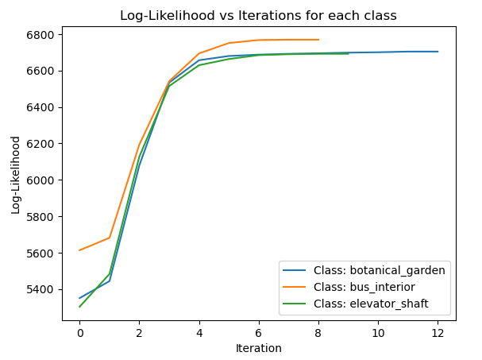
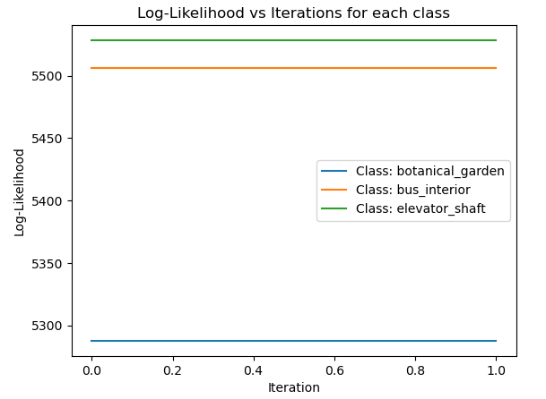
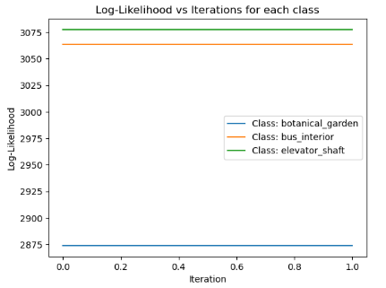
Iteration Vs Log-Likelihood Graph:
K=32
K=16
K=8
K=4
K=1
K=2

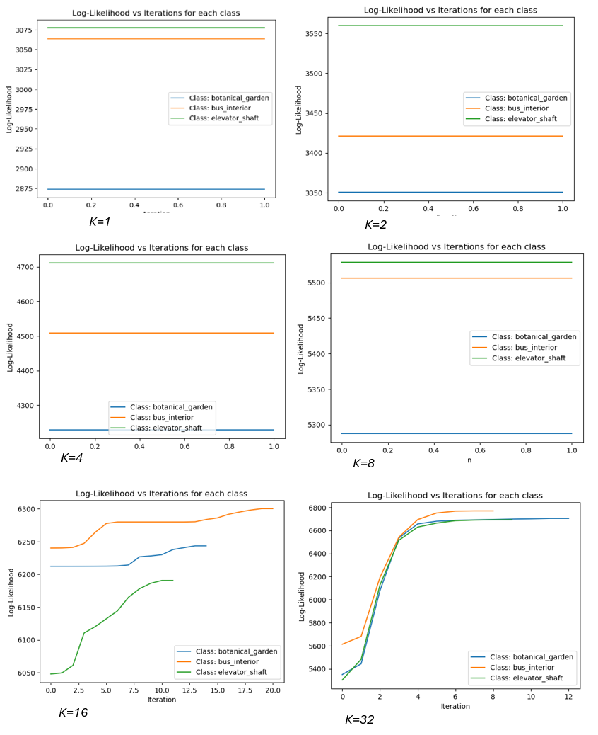

- Flat Log-Likelihood Curves for All Classes:
- All three curves (for Botanical Garden, Bus Interior, and Elevator Shaft) are flat, which means that the log-likelihood values did not change across iterations.
- This implies that the algorithm converged immediately after the first iteration or did not proceed with iterative updates, which is expected when we use only one cluster (K=1).
- Inference: With just one cluster, the initial model likely represented the entire data distribution quite well, and there was no need for additional iterations to improve the log-likelihood.

4.Performance Matrix:
- Confusion Matrix, precision, Recall and F-measure:

Actual  Predicted Class1 Class2 Class3  Class1 40 7 3  Class2 13 30 7  Class3 12 12 26  Table 1:Confusion Matrix | Class1 Class2 Class3  Precision 0.6154 0.6122 0.7222  Recall 0.8000 0.6000 0.5200  F-Measure 0.6957 0.6061 0.6047  Table 2:Analysis

Accuracy | 64.00%
Mean Precision | 0.6500
Mean Recall | 0.6400
Mean F-Measure | 0.6355
Table 3:Result
(a) GMM using 2 cluster: botanical_garden,bus_interior and elevator_shaft
Actual  Predicted Class1 Class2 Class3  Class1 36 8 6  Class2 6 29 15  Class3 9 13 28  Table 1:Confusion Matrix | Class1 Class2 Class3  Precision 0.7059 0.5800 0.5714  Recall 0.7200 0.5800 0.5600  F-Measure 0.7129 0.5800 0.5657  Table 2:Analysis

Accuracy | 62.00%
Mean Precision | 0.6191
Mean Recall | 0.6200
Mean F-Measure | 0.6195
Table 3:Result
(b) GMM using 1 cluster: botanical_garden,bus_interior and elevator_shaft
Actual  Predicted Class1 Class2 Class3  Class1 50 0 0  Class2 44 3 3  Class3 43 0 7  Table 1:Confusion Matrix | Class1 Class2 Class3  Precision 0.3650 01.000 0.7000  Recall 1.0000 0.0600 0.1400  F-Measure 0.5348 0.1132 0.2333  Table 2:Analysis

Accuracy | 40.00%
Mean Precision | 0.6883
Mean Recall | 0.4000
Mean F-Measure | 0.2938
Table 3:Result
(c) GMM using 8 cluster: botanical_garden,bus_interior and elevator_shaft
Actual  Predicted Class1 Class2 Class3  Class1 50 0 0  Class2 49 0 1  Class3 49 0 1  Table 1:Confusion Matrix | Class1 Class2 Class3  Precision 0.3378 0.0000 0.5000  Recall 1.0000 0.0000 0.0200  F-Measure 0.5051 0.0000 0.0385  Table 2:Analysis

Accuracy | 34.00%
Mean Precision | 0.2793
Mean Recall | 0.3400
Mean F-Measure | 0.1812
Table 3:Result
(d) GMM using 16 cluster: botanical_garden,bus_interior and elevator_shaft
Actual  Predicted Class1 Class2 Class3  Class1 50 0 0  Class2 50 0 0  Class3 50 0 0  Table 1:Confusion Matrix | Class1 Class2 Class3  Precision 0.3333 0.0000 0.0000  Recall 1.0000 0.0000 0.0000  F-Measure 0.5000 0.0000 0.0000  Table 2:Analysis

Accuracy | 33.33%
Mean Precision | 0.1111
Mean Recall | 0.3333
Mean F-Measure | 0.1667
Table 3:Result
(e) GMM using 32 cluster: botanical_garden,bus_interior and elevator_shaft

- 32-dimensional Bag of Visual Words (BoVW) feature vectors:
- Take the 24-dimensional colour histogram feature vectors of all the training examples of all the classes.
- Group them into 32 clusters using K-means clustering algorithms.
- Now take an image, assign each 24-dimensional colour histogram feature vector to a cluster.
- Count the number of feature vectors assigned to each of the 32 clusters.
- This results in a 32-dimensional BoVW representation for that image.
- Normalise this vector by dividing it by the number of 24-dimensional histogram feature vectors in that image.
- Repeat this for every image in the training and test set.
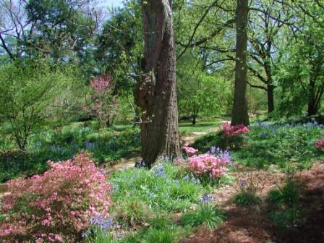
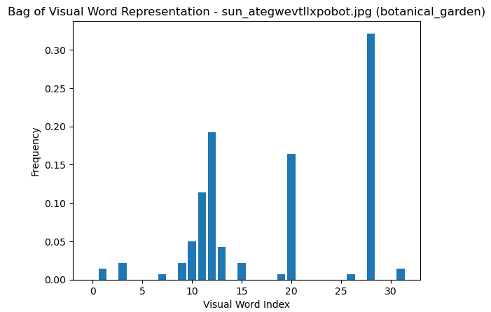
- 32-dimentional Bag of Visual Word Representation:
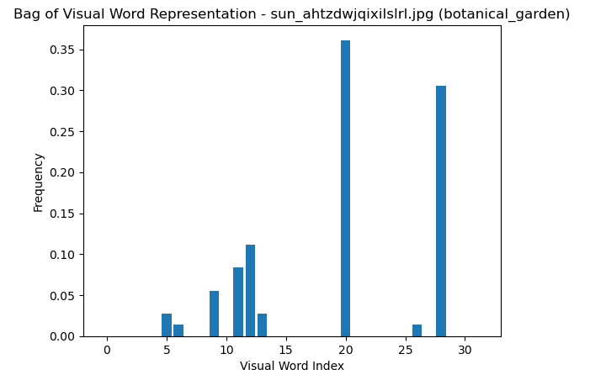
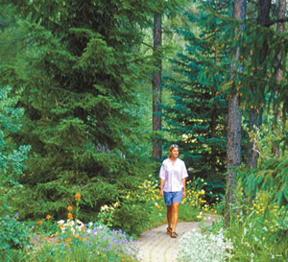

Dataset(2b) Bag of Visual Word for Class botanical_garden
Dataset(2b) Bag of Visual Word for Class bus_interior

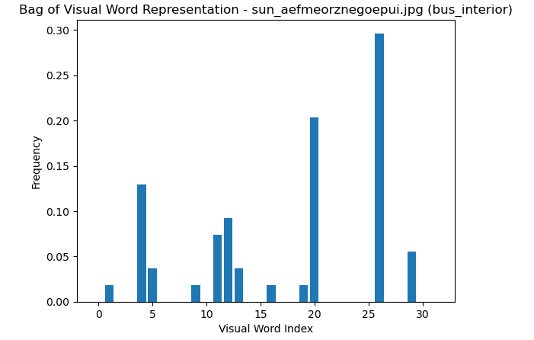
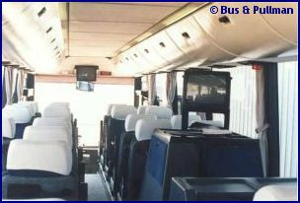

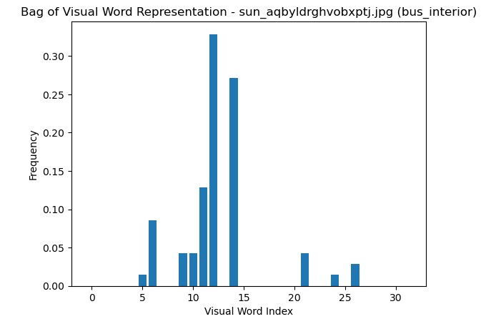
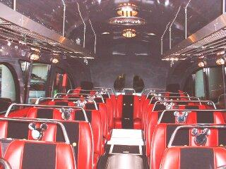
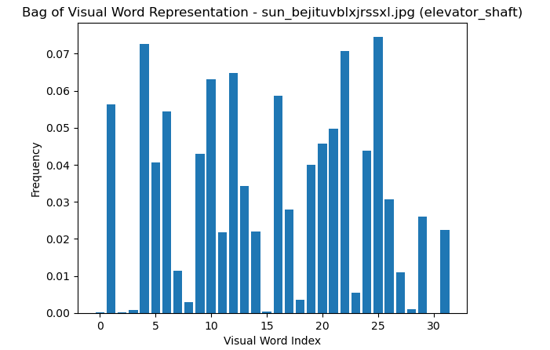
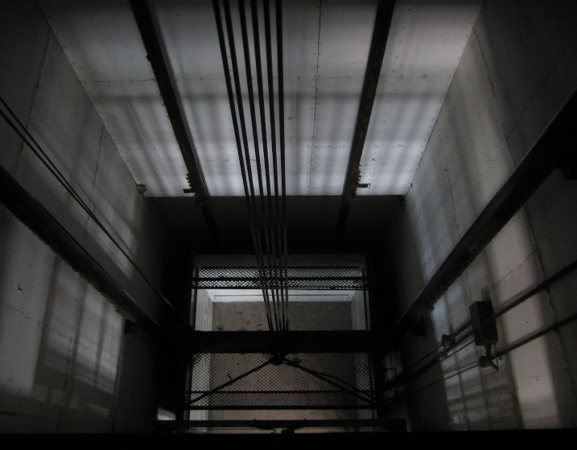
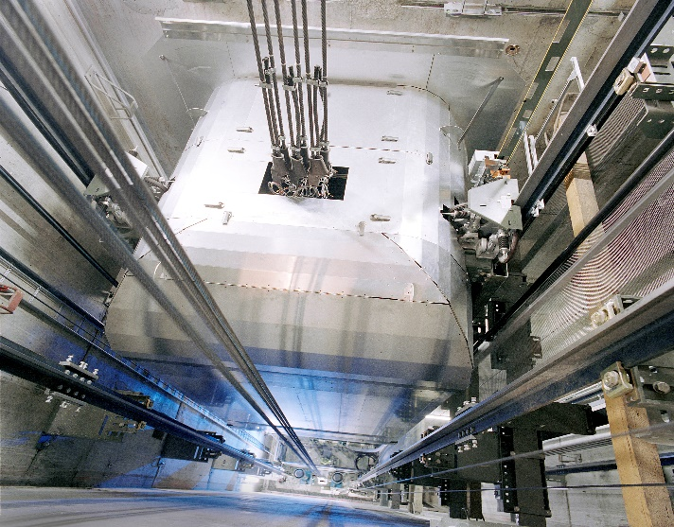
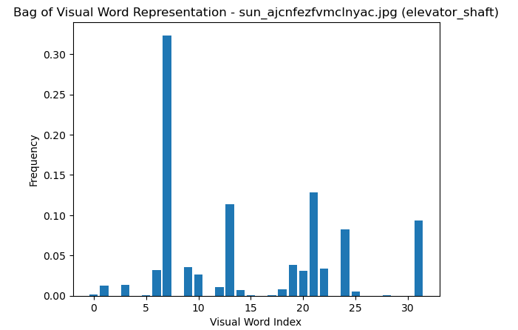

Dataset(2b) Bag of Visual Word for Class elevator_shaft
4 Experimental Results:

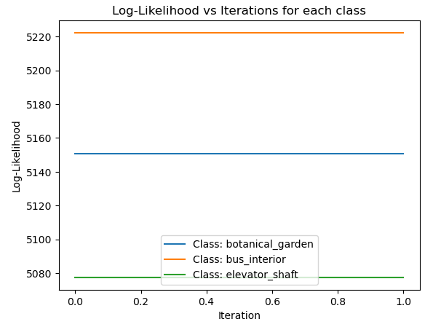
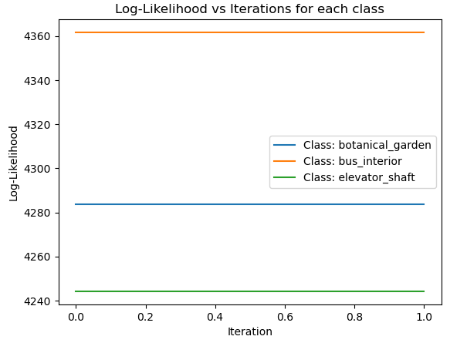
K=16
K=8
K=4
K=1
K=2
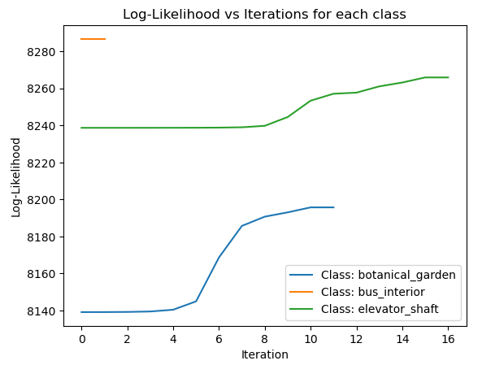
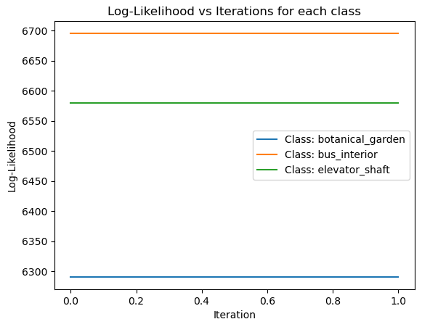
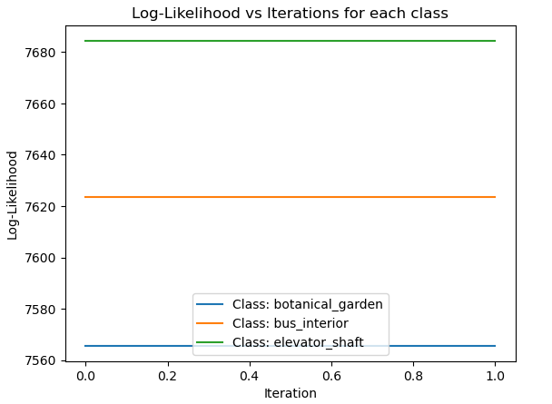

Iteration Vs Log-Likelihood Graph:

Inferences on plot of iteration Vs Log-likelihood:
Figure 12
- This indicates that the Expectation-Maximization (EM) algorithm has either converged in the first iteration or the initial parameter values already provide the best possible fit for the model given the data.
- This implies that the model's fit to the data varies across the classes, with bus_interior having the highest log-likelihood, suggesting that the GMM fits the data from this class better than the other two classes.
- In cases where the log-likelihood remains constant, it's often a sign that the model has reached a local maximum quickly, but increasing the number of clusters might yield a better fit and more iterative improvement.
- When using a more complex feature extraction method like Bag-of-Visual-Words, more clusters (i.e., a higher value of kkk) are usually required to capture the finer details in the data.

- Performance Matrix:
- Confusion Matrix, precision, Recall and F-measure:
Actual  Predicted Class1 Class2 Class3  Class1 40 7 3  Class2 5 37 8  Class3 5 18 27  Table 1:Confusion Matrix | Class1 Class2 Class3  Precision 0.8000 0.5968 0.7105  Recall 0.8000 0.7400 0.5400  F-Measure 0.8000 0.6607 0.6136  Table 2:Analysis

Accuracy | 69.33%
Mean Precision | 0.7024
Mean Recall | 0.6933
Mean F-Measure | 0.6915
Table 3:Resul
- GMM using 1 cluster: botanical_garden,bus_interior and elevator_shaft
Actual  Predicted Class1 Class2 Class3  Class1 28 6 16  Class2 2 24 24  Class3 3 18 29  Table 1:Confusion Matrix | Class1 Class2 Class3  Precision 0.8485 0.5000 0.4203  Recall 0.5600 0.4800 0.5800  F-Measure 0.6747 0.4898 0.4874  Table 2:Analysis

Accuracy | 54.00
Mean Precision | 0.5896
Mean Recall | 0.5400
Mean F-Measure | 0.5506
Table 3:Resul
(b) GMM using 2 cluster: botanical_garden,bus_interior and elevator_shaft
Actual  Predicted Class1 Class2 Class3  Class1 45 0 5  Class2 33 7 10  Class3 33 2 15  Table 1:Confusion Matrix | Class1 Class2 Class3  Precision 0.4054 0.7778 0.5000  Recall 0.9000 0.1400 0.3000  F-Measure 0.5590 0.2373 0.3750  Table 2:Analysis

Accuracy | 44.67%
Mean Precision | 0.5611
Mean Recall | 0.4467
Mean F-Measure | 0.3904
Table 3:Resul
(c) GMM using 4 cluster: botanical_garden,bus_interior and elevator_shaft
Actual  Predicted Class1 Class2 Class3  Class1 50 0 0  Class2 50 0 0  Class3 50 0 0  Table 1:Confusion Matrix | Class1 Class2 Class3  Precision 0.3333 0.0000 0.0000  Recall 1.0000 0.0000 0.0000  F-Measure 0.5000 0.0000 0.0000  Table 2:Analysis

Accuracy | 33.33%
Mean Precision | 0.1111
Mean Recall | 0.3333
Mean F-Measure | 0.1667
Table 3:Resul
(d) GMM using 8 cluster: botanical_garden,bus_interior and elevator_shaft
Actual  Predicted Class1 Class2 Class3  Class1 50 0 0  Class2 50 0 0  Class3 50 0 0  Table 1:Confusion Matrix | Class1 Class2 Class3  Precision 0.3333 0.0000 0.0000  Recall 1.0000 0.0000 0.0000  F-Measure 0.5000 0.0000 0.0000  Table 2:Analysis

Accuracy | 33.33%
Mean Precision | 0.1111
Mean Recall | 0.3333
Mean F-Measure | 0.1667
Table 3:Resul
(d) GMM using 8 cluster: botanical_garden,bus_interior and elevator_shaft

5.Conclusion
This project demonstrates the process of building a Bayes Classifier using GMM, where the parameters are initialized using K-means clustering. The classifier successfully learns the distribution of the data and classifies the test images with a high level of accuracy.
References
- Bishop, C. M. (2006). Pattern Recognition and Machine Learning. Springer.
- Murphy, K. P. (2012). Machine Learning: A Probabilistic Perspective. MIT Press.

